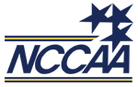
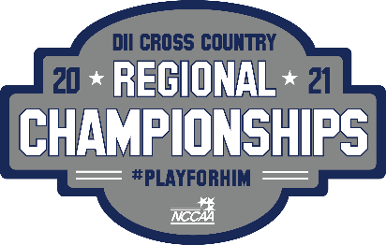

North Region NCCAA Regional Cross Country Championship
Date: Saturday, October 23rd 2021
Location: Faith Baptist Bible College
1900 NW Fourth St
Ankeny, IA 50023
Parking: Nettleton Athletic Center (gymnasium) parking lot
Race Times: Women’s 5k Race @ 12:00pm
Men’s 8k Race @ 1:00pm
Entries: Entries must be submitted online by Tuesday, October 19th @ Noon
http://theendresultsco.com/xc
Entry Fee: $15 per athlete, maximum of $75 per gender
Results: Race results will be posted at http://onlineraceresults.com/
Awards: Top 7 individual finishers (each race) will receive a championship plaque
1st place team in the men’s & women’s races will receive a championship plaque
Coach of the year for both men & women
Locker Room: Locker rooms will be available after 2:00 in Nettleton Athletic Center
Trainer: A certified athletic trainer will be onsite. Water and ice will be available for
competitors.
Meet Ryan Long – Faith Baptist Bible College Head Cross Country Coach
Director: Cell – (515) 528-4499 Email – longr@faith.edu
